What Causes Injection Molding Flash and How to Prevent It?

# Introduction

Injection molding is a crucial manufacturing process in today's world, contributing to the production of a wide range of plastic products across various industries. Injection molding is a process of producing parts by injecting molten material into a [mold](https://en.wikipedia.org/wiki/Molding_(process)). Injection molding uses a ram or screw-type plunger to force molten [plastic](https://en.wikipedia.org/wiki/Plastic) or [rubber](https://en.wikipedia.org/wiki/Rubber) material into a mold cavity and solidifies into the shape of the mold cavity. This process is widely used due to its high precision for complex shapes. However, there are defects that occur when molten plastic flows out of the mold during injection and solidifies. This defect, known as injection molding flash, degrades the final product's quality and requires additional steps to trim or remove the excess material. Injection molding flash is the thin layer of extruded excess material on the parting line or any other two dissimilar faces where the mold meets and forms a boundary. The removal of injection molding flash is crucial in today's plastic industries to ensure product quality and performance.

# Understanding Injection Molding Flash

Injection molding flash, also known as flashing, is a defect in molding process which occurs when excess material, usually in a thin layer, attaches itself to the product, particularly along the parting line where two surfaces meet. This can also happen in other areas where different shapes of the mold converge. The causes of injection molding can range from incorrect flow rates and high pressures during injection to flaws in mold cavities or the equipment used. The other causes might be material viscosity, pressure, and speed variations.

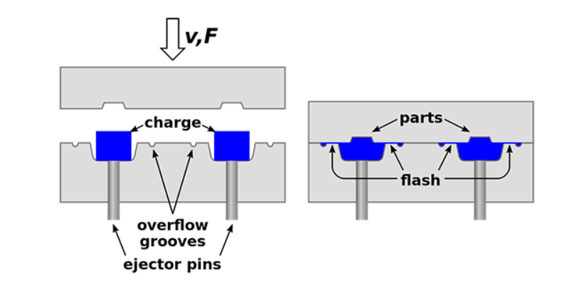

Figure 1 Flash in injection molding (source: <https://go4mould.com/flash-injection-molding>)

Flash has a direct impact on both product quality and production efficiency. Its presence doesn’t only compromise the appearance of the product but also creates functional issues. The excess material in the product surface disrupts the intended design and dimension of the part. It also obstructs moving parts affecting its functionality. An additional process called de-flashing is required to minimize the flash occurrence. This involves cutting, grinding, and breaking to remove the excess material. Additional processes mean additional time and costs of production which leads to slower production rates.Top of Form

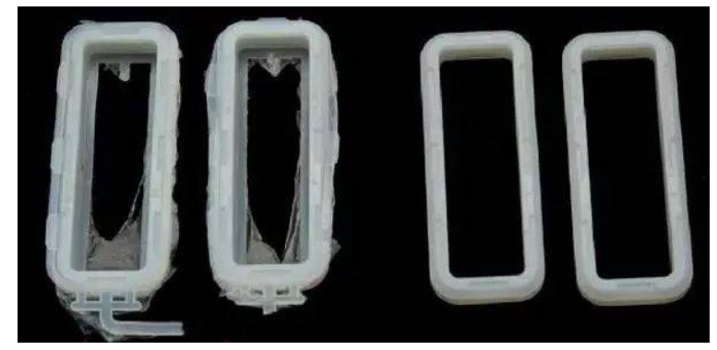

Figure 2 Quality comparison due to flashing (source: <https://guanxin-machinery.com/injection-molding-flash-trouble-shooting-and-the-remedies/>)

# Causes of Injection Molding Flash

## Excessive injection pressure:

Excessive pressure is a significant factor leading to the occurrence of flashing in injection molding process. When the injection speed and pressure are too high, the molten plastic gets pressurized and forces its way between the mold surfaces. This leads to the creation of flash in the form of thin layer of excess material between the mold surfaces.

## Inadequate clamping force:

Inadequate clamping force is the key cause of the injection molding flash in most cases. When clamping force is not enough, molding halves don’t close completely. This creates gaps that lets the molten plastic to leak during the injection process. This leaked material solidifies at the parting line creating flashes. Also, uneven clamping force is also a major factor in the creation of flashes. Uneven clamping force means pressure imbalances within the mold cavity during the injection process. This imbalance permits the material to flow in the area of low clamping force as plastic tries to escape through the easiest route.

## Mismatched mold halves:

An injection molding flash occurs when molten material escapes the mold cavity through the parting line. It occurs where the two halves of the injection mold separate to release the plastic part. If they're misaligned and mismatched, the gaps are formed enabling molten material to leak and form flash.

## Wear and tear of the mold:

Repeated use and continuous operation of the mold over time leads to wear and tear in the mold. This creates misalignment and gaps at the parting line. The molded parts become less precise than the intended design. This kind of wear and tear permits the molten plastic to seep through the gaps during injection creating an undesired flash.

# Prevention and Remedies for Injection Molding Flash

Injection mold flashing is a significant concern in manufacturing process. Effective prevention of injection molding flash is necessary to ensures top product quality, higher production rate and cost savings production. This section will highlight the prevention method and remedies that manufacturers can adapt to avoid injection molding flash.

## Proper maintenance of the mold:

The mold should be maintained at regular intervals to prevent flash. Proper inspection should be done over time to check if there are unwanted gaps and misalignments due to the wear and tear of the mold. Actions like cleaning and replacement of worn parts should be conducted to minimize the likelihood of flash formation.

## Optimizing injection parameters:

The injection parameters like injection pressure and clamping force play a vital role in the injection process. Optimizing these parameters based on the specific material properties and part geometry can reduce the likelihood of flash occurrence and achieve uniform distribution of molten plastic. Also, the parameters like injection speed, pack and hold pressure, cooling time, gate design and location should be adequately maintained.

## Ensuring precise mold halves alignment

Misaligned mold halves create openings for the molten material to escape through it during the injection process. So, accurate alignment of mold halves is critical for flash prevention. Proper alignment means no openings in the parting line area preventing material leakage. This can be achieved using features like guide pins and bushings in the mold design, these components provide precise points of contact. Also, consistent temperature should be maintained to prevent differential in thermal expansion.

## Regular Quality Checks and Testing

Quality checks and testing is essential for the early detection and mitigation of flash-related issues. Regular checks and testing during and after the injection process can quickly identify flashes in products. Visual inspection, measurements, and other testing methods enable manufacturers to detect flash defects promptly and take immediate corrective actions.

The prevention and remedies for injection molding flash require a multifaceted approach. Along with the above methods, there are other factors to be considered to minimize the occurrence of flash like increasing viscosity of flash, adequate vent system, barrel and nozzle temperature, etc.

# Case Studies

Flash occurrence has been a persistent challenge in the history of injection molding industry, affecting various sectors including automotive, electronics, and even toy manufacturing. The following case studies from these industries highlight instances of flash occurrence and successful strategies for its prevention.

## Case Study 1: Automotive Interior Components

Injection molding flash has had a significant impact on the automotive industry for several decades, especially in the 1970s and 1980s. The production companies were facing many production defects and one of them was recurring flash issues. The interior parts required complex molds due to their intricate designs. This led to increased post-processing efforts, extended cycle times, and a rise in rejected parts. During this period, the benefits of lightweight plastic components with the need for high-quality production was the driving factor in the automotive industry. Automotive companies like General Motors, Ford, Toyota, Volkswagen, and FCA encountered flash-related issues in their components. These companies, along with many others in the automotive industry, navigated the challenges of flash occurrence during the transition to plastic components.

### Prevention Strategy:

The following methods were adopted to tackle the flash issue:

1. Mold Design Optimization: The molds were designed with a focus on smoother parting lines and improved gate placement. An enhanced venting system was made to minimize the likelihood of plastic leakage during injection.
2. Precision Clamping: The clamping force was calibrated precisely to ensure uniform mold closure and this led to the elimination of gaps that contributes to flash.
3. Parameter Tuning: Injection parameters such as pressure, speed, and cooling time were systematically adjusted through iterative testing.
4. Real-time Monitoring: Advanced sensors were integrated into the molding process to monitor pressure, temperature, and material flow in real time. This allowed operators to immediate adjustments if any deviation was detected.
5. Operator Training: The injection molding operators were trained to identify early signs of flash. They took corrective action whenever necessary.

## Case Study 2: Consumer Electronics Casing and toy industries

Consumer electronics companies have been using plastic components as their casing or enclosure. These companies had to compromise on their quality for several years due to flash-related issues in their components. The flash occurrence was particularly problematic in thin sections and complex geometries, affecting the overall aesthetic and functionality of the casings. During the 1980s and 1990s, Sony, a renowned consumer electronics manufacturer, encountered flash-related challenges while producing plastic casings for devices like televisions and audio equipment. As the industry transitioned from metal to plastic, flash became a concern due to the intricacies of electronic casing designs and the need for precise part fittings. However, the company tackled these issues due to significant growth in the injection molding process and prevention strategies. In another case, toy manufacturing industries are encountering the issues of flash-related issues. Due to a competitive price war, these companies choose to produce the toys at low costs which results in poor quality and flash-related issues. Some renowned companies like LEGO, Mattel, Hasbro, etc. have successfully tackled this by implementing prevention strategies to deliver quality toy products.

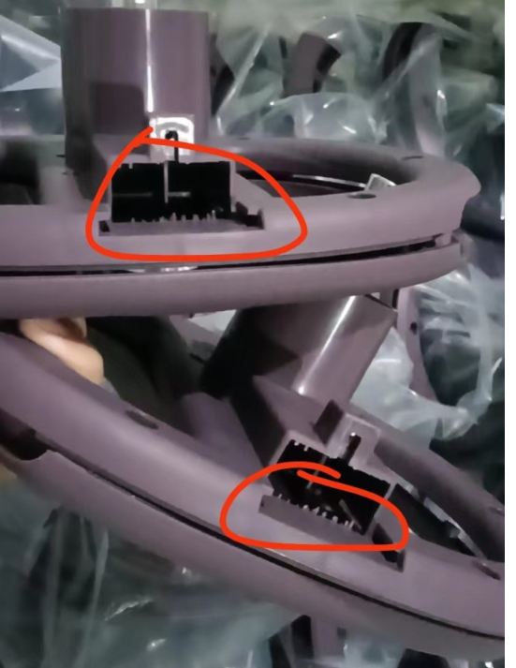

Figure 3 flash defect in toy (source: https://www.linkedin.com/pulse/12-injection-molding-defects-how-prevent-hem-mandy/)

### Prevention Strategy:

The company adopted innovative strategies to prevent flash in this scenario:

1. Mold Flow Analysis: The advanced use of mold flow simulation software to analyze the plastic flow pattern within the mold cavity was done. This analysis provided insights into potential areas prone to flash formation.
2. Temperature Control: Precise mold temperature control was implemented to ensure uniform cooling and solidification of the plastic material. This helped in reducing the chances of flash occurrence.
3. Insert Molding: Insert molding techniques were utilized. Specific areas prone to flash were reinforced with stronger materials. It reduces the chances of material escape during the injection.
4. Optimized Venting: Mold vents were strategically placed to facilitate the escape of trapped air and prevent pressure buildup. It led to less formation of flashes comparatively.
5. Material Selection: A material with suitable flow properties was selected. It reduced the likelihood of excessive pressure buildup and flash.

These case studies highlight that flash prevention strategies are adaptable across various industries. With proper consideration of mold design, material properties, and part intricacies by implementing a combination of design improvements and parameter optimization manufacturers can successfully prevent flash occurrences and produce high-quality injection-molded products.

# The Role of Technology in Preventing Injection Molding Flash

Advanced molding machines are essential in preventing injection molding flash in today’s world. These machines are equipped with precise control systems and automated features that enhance molding accuracy. They offer improved clamping force control, ensuring proper mold closure and reduced chances of flash occurrence. Additionally, these advanced machines incorporate advanced pressure and temperature sensors that aid in real-time monitoring and adjustment of molding conditions during injection. These advanced molding machines utilize advanced servo-motor technology to provide precise control over clamping force and injection speed.

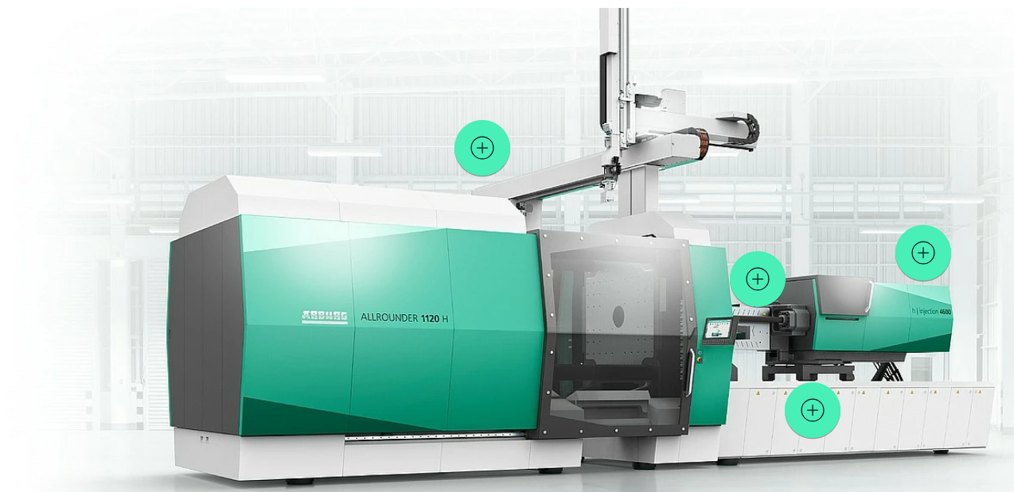

Figure 4 HIDRIVE hybrid ALLROUNDER injection molding machine (source: https://www.arburg.com/en/product-world/injection-moulding-machines/hybrid-machines/)

Software plays a critical role in flash prevention by enabling precise control over molding parameters. Process monitoring software continuously tracks key variables such as temperature, pressure, and injection speed. Moreover, software-driven simulations and virtual prototyping help in designing molds that minimize flash risks.

The VHX Series 4K Digital Microscope, by KEYENCE, can measure highly accurate 3D shapes on the submicron order and profiles of defective parts using high-definition images. Even microscopic flashes from melted plastic can be quantitatively measured and inspected, even when they occur due to distortion in the mold or insufficient clamping force. The acquisition of detailed 3D information on the defective part can aid in quickly detecting the cause, allowing for preventive measures.

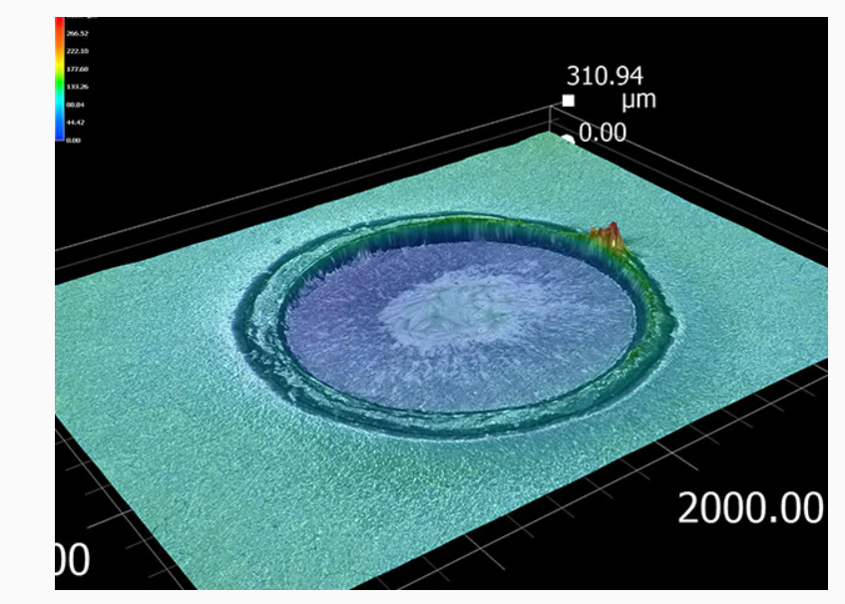

Figure 5 3d measurement and display of flash (source :https://www.keyence.com/products/microscope/digital-microscope/industries/chemistry/molding-defects.jsp)

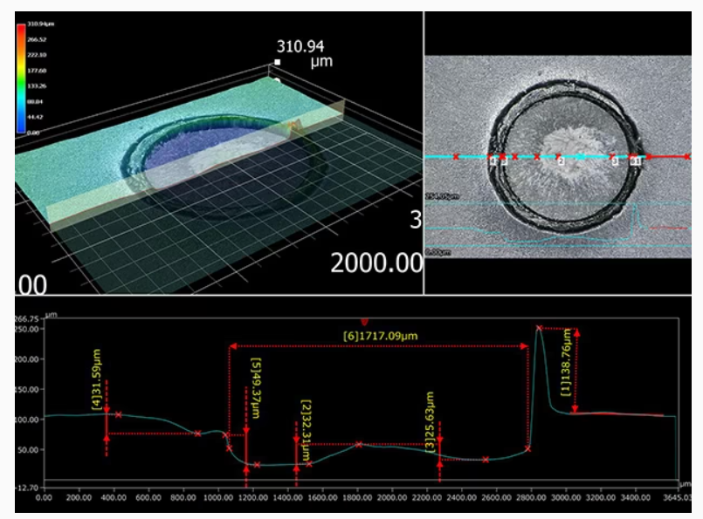 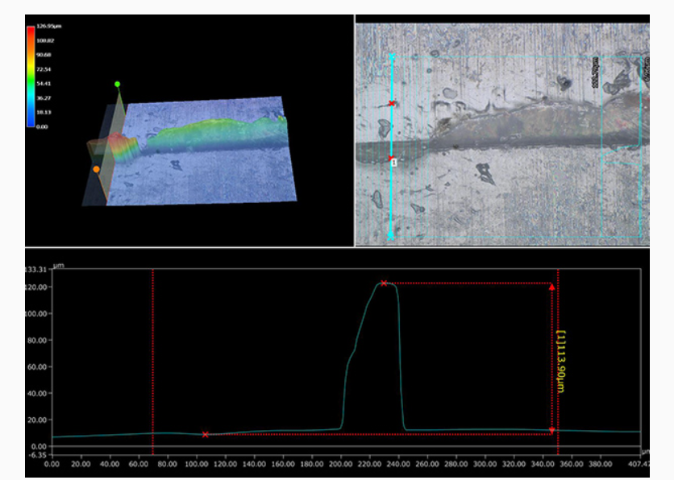

Figure 6 Profile measurement of flash (source: https://www.keyence.com/products/microscope/digital-microscope/industries/chemistry/molding-defects.jsp)

# Conclusion

In modern manufacturing, injection molding flash is a persistent challenge that compromises product integrity and efficiency. This defect disrupts functionality of the intended product and requires additional processing steps. However, this challenge can be overcome by maintaining molds and optimizing parameters. The case studies above highlight the importance of design enhancements, parameter tuning, and quality control. Ultimately, this article reflects the harmonious collaboration between human expertise and technological innovation in the pursuit of flawless manufacturing outcomes.